Step 1 – We will run the instance launched with window AMI
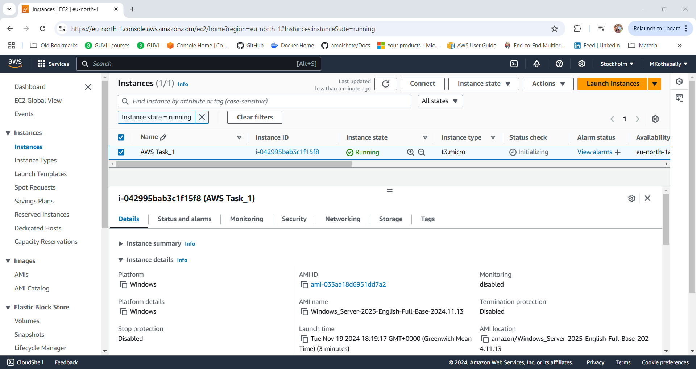
Step 2 – Right click on the instance and select connect. And go to tab RDP client.
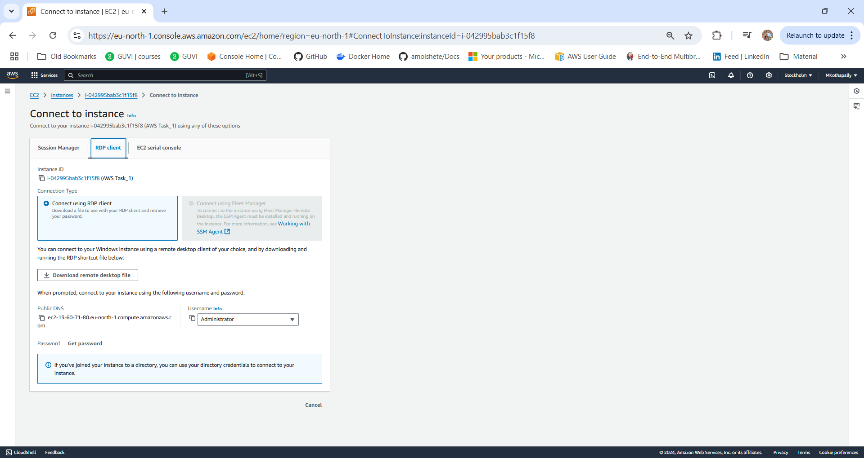
Step 3 – Click on download remote desktop file
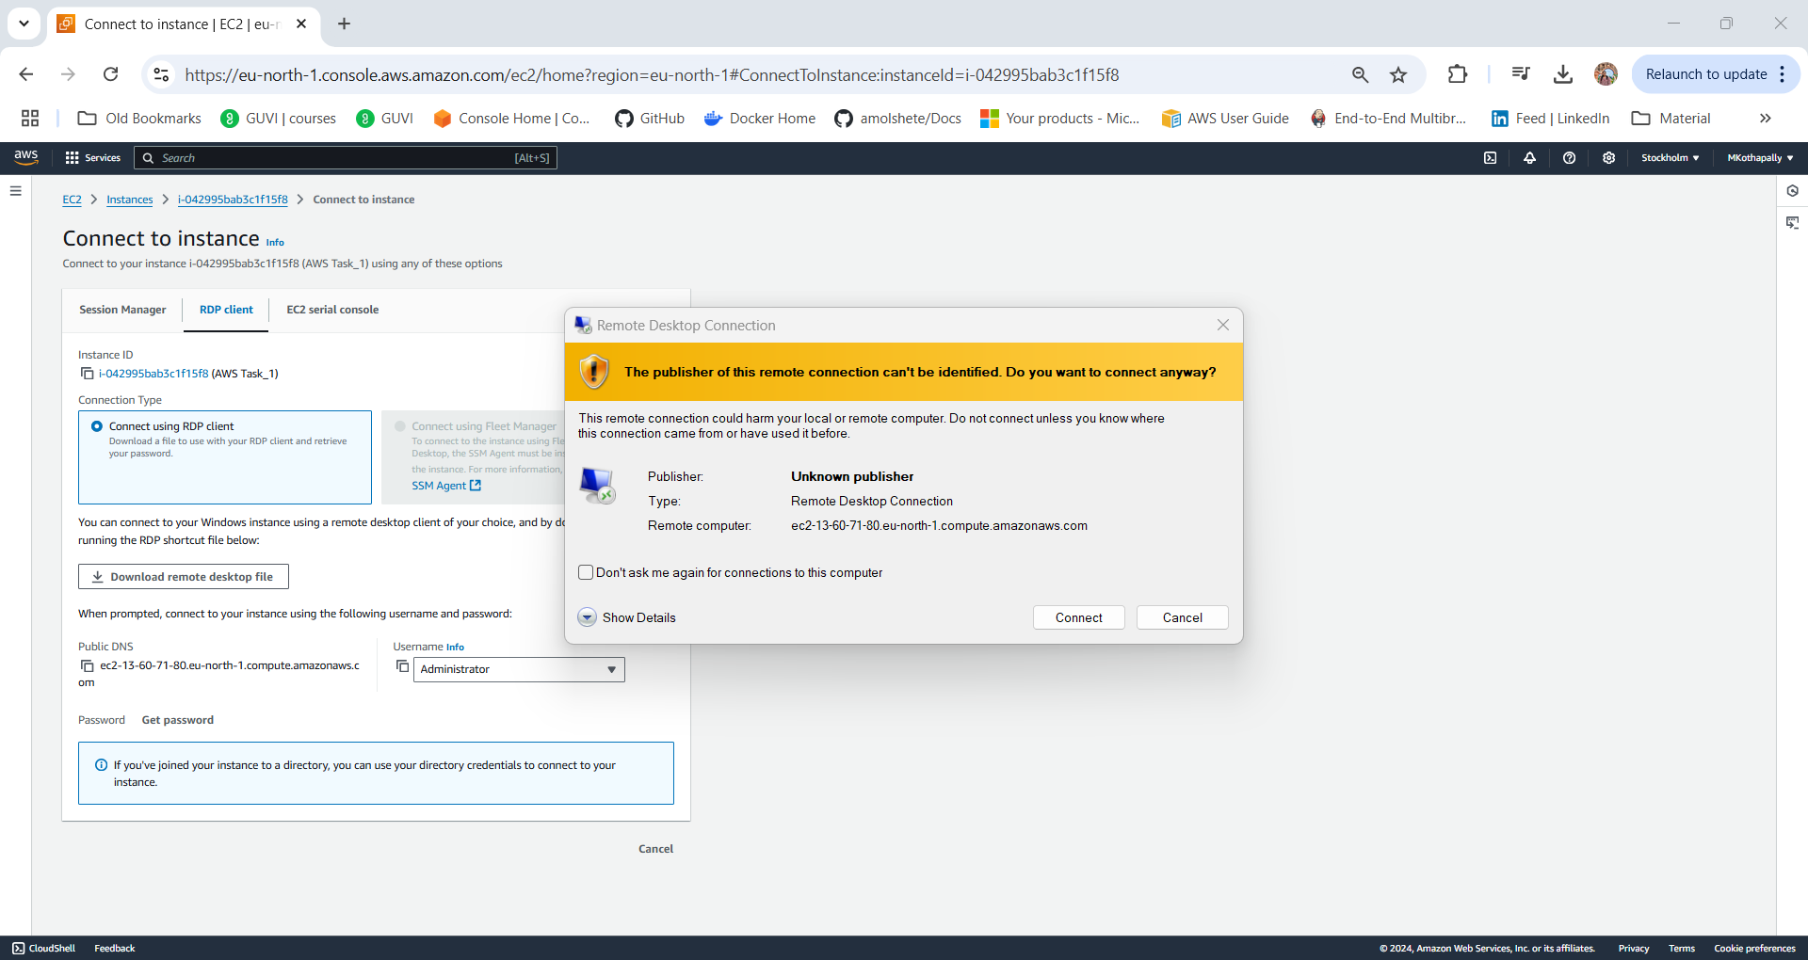
Step 4 – Select get password and enter the private key of the key pair created for windows AMI
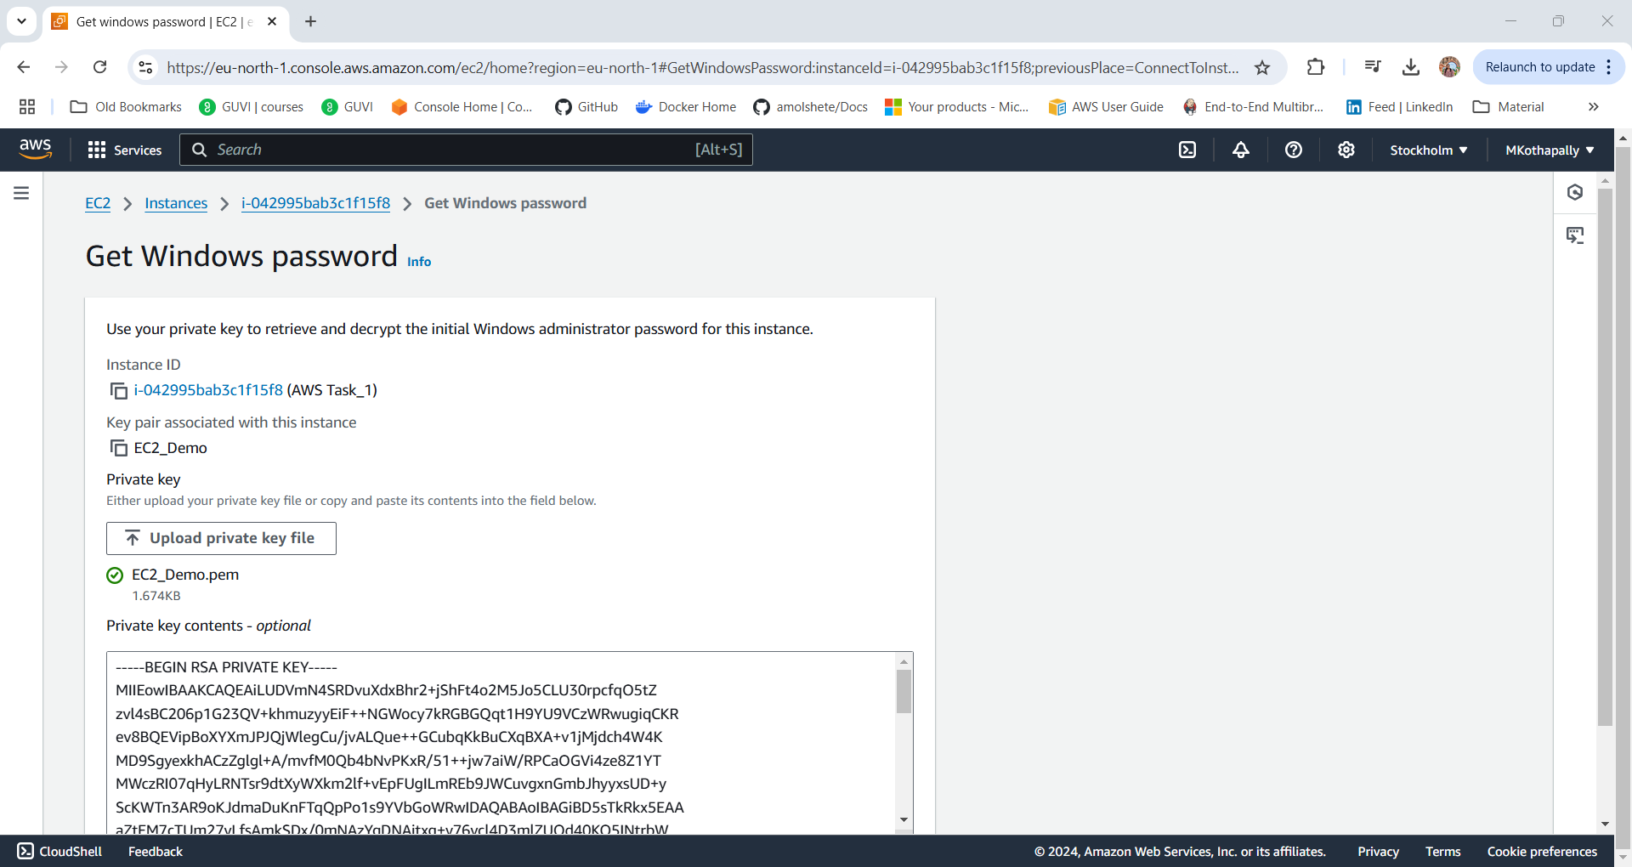
Step 5 – Once we copy the password created and login with admin we see that the RDP session launched successfully
